DISTRICT ASSEMBLY  AGENDA |  | April 5, 2016  3:00pm  Location: ATTC
Attendance: See Sign In Sheet
TOPIC | DISCUSSION
Call to Order -Stanskas
Chancellor’s Report
Approval of Minutes – 3/1/16

Once approved, minutes and materials will be posted on the District web-site: http://www.sbccd.org/District_Faculty_,-a-,_Staff_Information-Forms/District_Committee_Minutes/District_Assembly
OLD BUSINESS
Click here to view CCLC Policies & Procedures

- Policies & Procedures for 2nd Read and Approval
- BP/AP 3820 Gifts and Donations
- AP 4102 Career and Technical Education Programs (1st read Dec)
- BP/AP 5015 Residence Detemination (1st read Dec)

NEW BUSINESS  Click here to view CCLC Policies & Procedures  - Policies & Procedures for 1st Read  - BP 3225 Awards  - BP/AP 3225 Institutional Effectiveness  - BP/AP 3501 Campus Security and Access  - BP 3540 Sexual and Other Assaults on Campus  - BP/AP 4300 Field Trips & Excursions  - AP 5012 International Students  - BP 5205 Student Accident Insurance  - BP/AP 6150 Designation of Authorized Signatures  - BP/AP 6200 Budget Preparation  - BP/AP 6320 Investments  - BP 6800 Occupational Safety  - Policies & Procedures Deemed Academic & Professional Submitted for Information  - BP/AP 5140 Disabled Student Programs and  Services  - AP 5011 Admission and Concurrent Enrollment of HS and Other Young Students  - BP/AP 5035 Withholding of Student Records  - BP/AP 5052 Open Enrollment  - District Assembly Nominations & Elections (constitution attached with nomination form)  - Approval of Questions for Committee Evaluation (attached) | 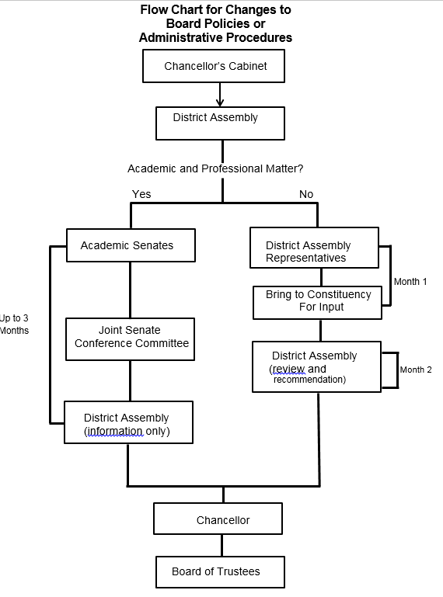
INFORMATION

1. AP 2510 Collegial Consultation (updated SBVC Mission Statement as approved by the Board 3/10/16)
2. Board of Trustees Meet & Greet with District Assembly
o April 14, 2016 @ CHC LRC 231 @ 1-2pm

REPORTS
- AB 86 Update
- Human Resources Update
- Calendar Committee Update
- Non-Credit Updates from Senates
- District Budget & Enrollment Update
- Staffing Plan Update
- Academic Senates
- Classified Senates
- Student Senates

WRITTEN DISTRICT REPORTS
- EDCT (attached)
- District Budget & Enrollment Update (attached)

PUBLIC COMMENTS
District Assembly welcomes public comment on any issue within the jurisdiction of the District. Comments must be limited to five (5) minutes per speaker and twenty (20) minutes per topic if there is more than one speaker. At the conclusion of public comment, staff may be asked to review a matter or for that matter to be put on a future agenda. As a matter of law, members may not discuss or take action on matters raised during public comment unless the matters are properly noticed for discussion or action in Open Session. Anyone who requires a disability-related modification or accommodation in order to participate in the public meeting should contact the Chancellor’s Office at (909) 382-4091 as far in advance of the meeting as possible.

FUTURE AGENDA ITEMS
- AB 86 Update
- District Strategic Plan Update (February)
- Educational & Facilities Master Plan Update (February)
- District Budget & Enrollment Update (April)
- Policy & Procedure Tracking Software (May)
- Annual approval of 6-year AP/BP review schedule (September)
- Fiscal Services Update (written reports Feb, May, Aug, Nov)
- KVCR Update (written reports Feb, July)
- Police Department Update (written reports Apr, Sept)
- TESS Updates (written reports May, Oct)
- Human Resources Update (written reports Jan, Apr, July, Oct)
- EDCT Update (written reports Apr, Dec)

ADJOURN

